Name: ______________________________________ | Date: ___________________

Reading: How does touch work?

Do you know anyone who is blind? How do they navigate the world? People who are blind can use other senses, such as touch and hearing, to accomplish their daily goals. People with limited or no vision may use their fingers to read by feeling patterns of raised dots in books, on restaurant menus, or on signs. These raised dots are part of a reading and writing system called Braille. Braille allows people who are visually impaired to read by pressing their fingers onto sequences of raised dots that represent letters, forming words and sentences. The Braille alphabet is shown in the figure below. Do you think you could feel your name in raised dots using this system?

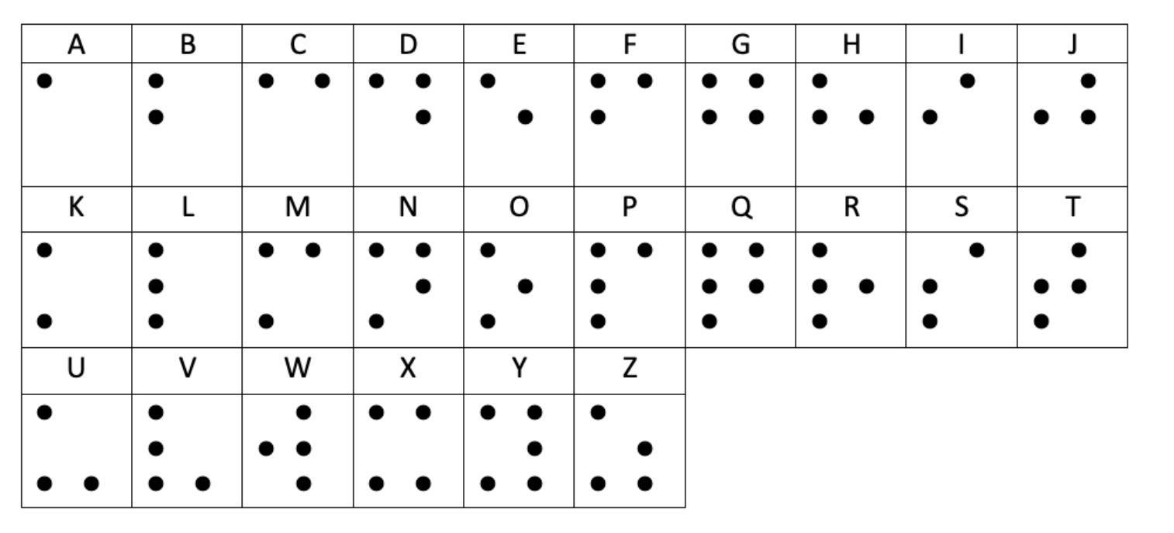
If you are sighted, you also have the ability to recognize objects using only your sense of touch. If you close your eyes, you could probably identify a cell phone, a pencil, or a feather using only your fingers. You could press on the smooth glass surface of the cell phone, feel the pointed end of the pencil, and feel the lightness of the feather. How are you able to do this just by bringing those objects into contact with your skin?

In your prior work in OpenSciEd Unit 6.6: How do living things heal? (Healing Unit), you figured out that there are nerves that run all throughout our bodies. You also figured out that these nerves are made up of cells and that there are different types of nerve cells. Some of these nerve cells can be found in our skin and contain specialized structures, called sensors, that help us detect different feelings like pain, temperature, and force. One square inch of our skin contains about 200 sensors for pain, about 10 for temperature, and about 15 for light touches and forces applied to our skin.
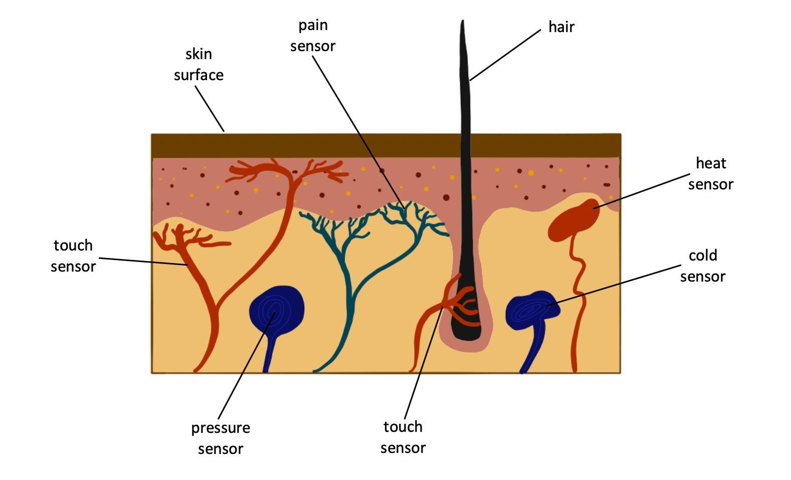
Why do you think there are so many pain receptors compared to temperature sensors in our skin? You may be thinking that it would be a good thing to be less sensitive to pain, but this would actually be very dangerous. Imagine tripping, falling down, and bruising your arm due to the peak contact forces between your arm and the ground. If you were unable to feel pain, you might not know you were hurt. You might go about your day causing even more damage to that area of your arm. There are some people who are unable to feel pain due to a very rare condition called congenital analgesia. These people must be very careful not to hurt themselves.

The heat and cold sensors in your skin help alert you to pull away from objects that are too hot or too cold to safely touch. They also help you regulate your body temperature. They signal when to put on a warm coat or when to seek out shade on a hot, sunny day.

The specialized pressure and touch sensors in nerve cells detect contact forces acting on them. These sensors are very sensitive to any deformation they experience in their structure. Touch sensors that are attached to hairs deform as the hair comes in contact with something else and moves. This can be something as gentle as the push from moving air in a light breeze.

But how do these sensors help us perceive the pressure, pain, or temperature they are detecting? When these sensors are deformed due to a contact force acting on them, they send a chemical signal to the nerve cells that they are connected to. These nerve cells are called neurons. An image of the structures that make up a neuron is shown below.

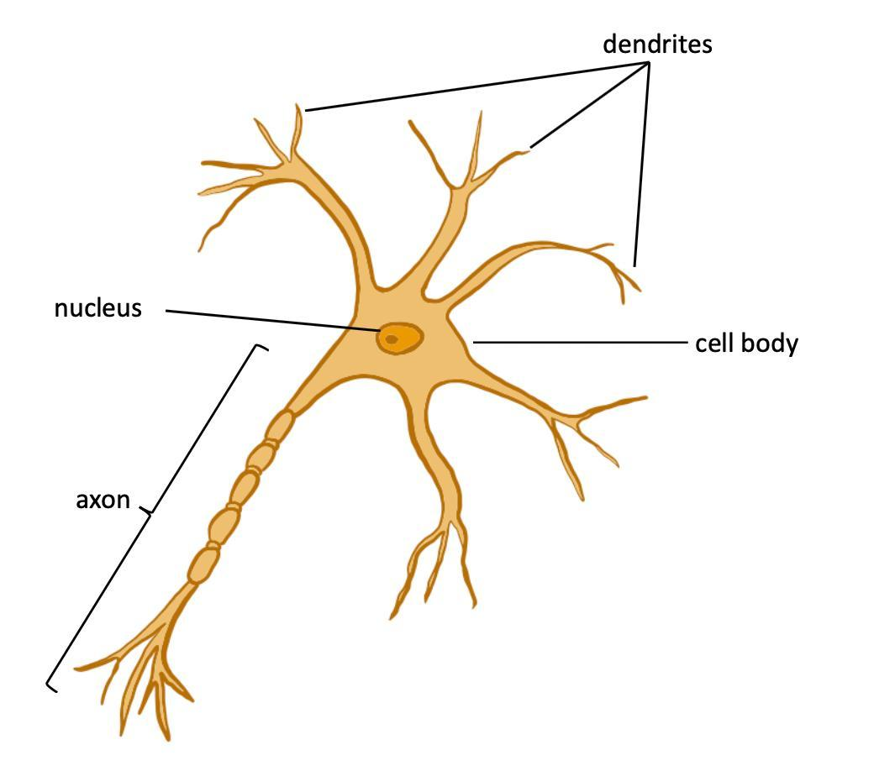
Neurons are very long cells compared to the skin, blood, bone, and muscle cells you have seen in Healing Unit or the cells of the small intestine you have seen in Inside Our Bodies Unit. Neurons have specialized ends that can send or receive chemical signals throughout your body to relay information. The axon of all of these neurons is the structure that sends outgoing signals to other neurons. And the dendrites of all of these neurons are the structures that receive incoming signals from other neurons. Neurons that contain sensors in your skin send information to neighboring neurons which, in turn, send signals to your brain.

Signals from your senses are always being sent to your brain. Your brain interprets the signals it receives from your senses to determine what you sense, or feel, with your skin. At that point, your body uses that feeling to determine what to do next. Deciding how to respond to anything we sense requires our brains to hold onto the information it receives from the neurons that transmit signals to it from all of our sensory receptors. Our brains do this by activating different groups of neurons to help us register and record these experiences as memories.

Our memories can include images, sounds, smells, ideas, and feelings. Some memories can be very fleeting. If you close your eyes after seeing something, you may be able to imagine what you saw in your mind. But the image may fade quickly. You may recall the wording of a few sentences you read while you are actively paying attention. But after reading a whole chapter of a book, you probably will not recall the exact wording of any of the sentences or the words the author used. But you can recall the gist of what you read.

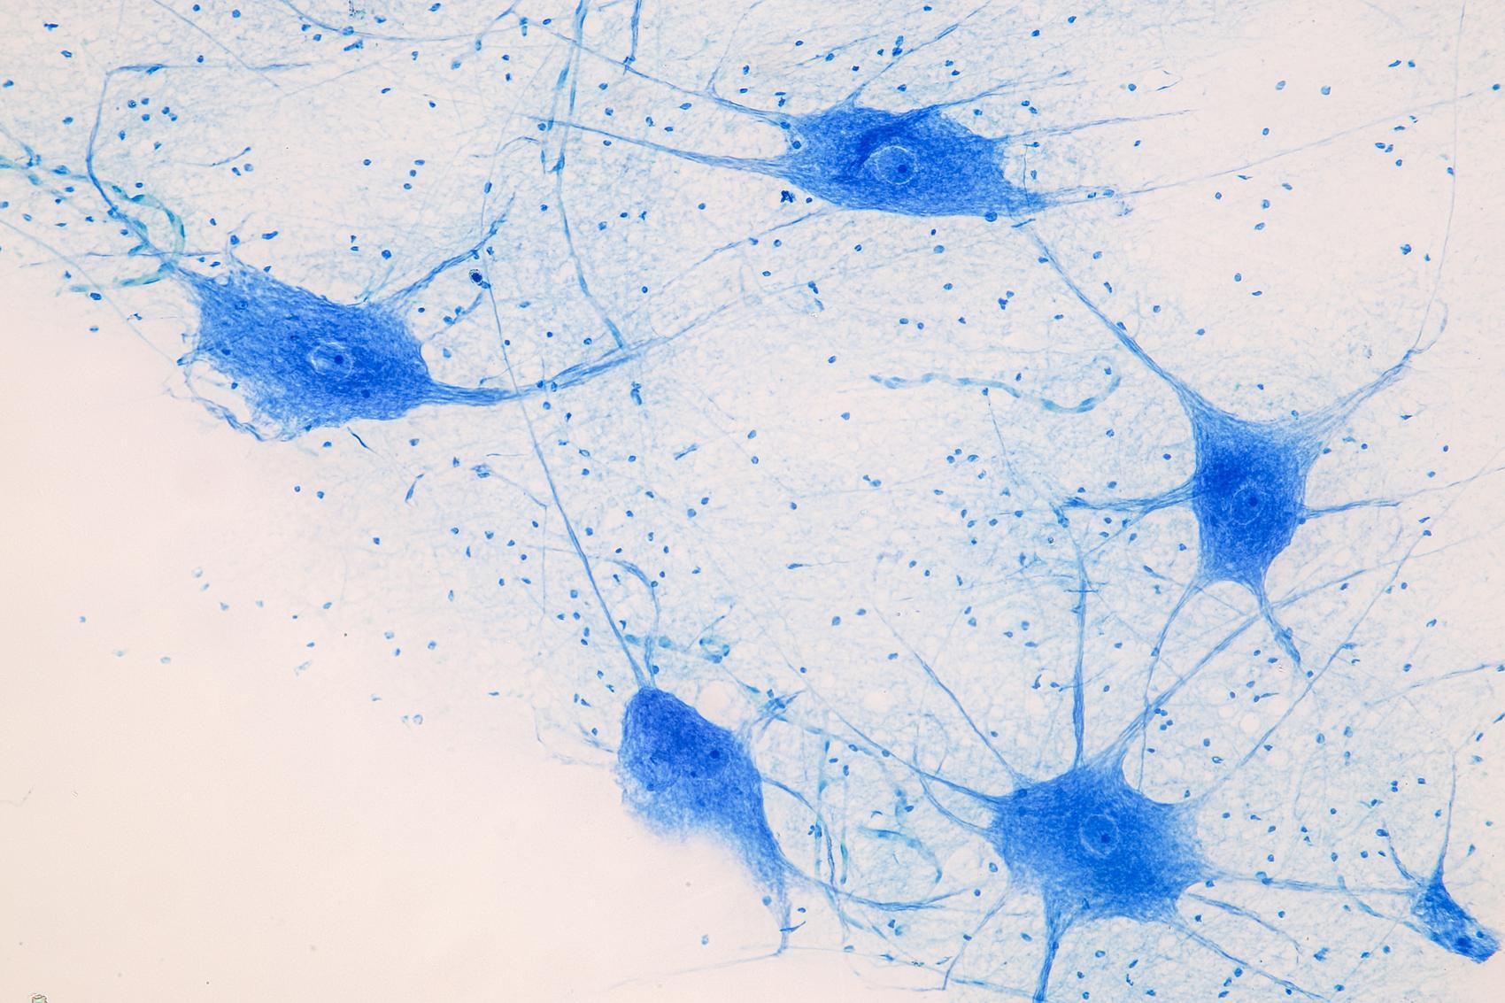
There are billions of neurons that make up our brains. The interactions between their axons and dendrites are responsible for the storage and retrieval of all of our memories. We draw on and add to our memories when we learn new skills, develop new ideas, and think more creatively. Your memories are what makes you “you.”

Your brain can respond by sending signals back out to parts of your body to react to what you are feeling through a different type of neuron called a motor neuron. The motor neurons send signals that can trigger a response in the muscle cells in different parts of the body.

Imagine you wake from sleep feeling uncomfortable pressure on your shoulder from being in the same position for too long. You decide to roll over to get more comfortable. Or imagine you wake up from feeling too cold and you decide to pull on more blankets. To do either of these things, your brain needs to send a signal through motor neurons to the corresponding muscles in your body in order to make them move.

Our bodies can quickly respond to signals to protect us before we have to decide what we need to do. In many cases when we need to react to keep from hurting ourselves, an automatic response signal is sent directly to motor neurons when an incoming signal is detected that requires a fast reaction. For example, if your hand touches something sharp with too much force or a surface that is too hot, the incoming signal immediately triggers a signal in outgoing motor neurons that causes the cells in your arm muscles to contract quickly. This results in you pulling your hand away before you even realize what happened. You did not need to make a decision to pull your hand away in order for this to happen - this is a reflex.

Signals from our senses are always being sent to our brains, whether or not a reflex happens. Our brains interpret the signals they receive from our senses as feelings, and that is how we can decide how else we want our bodies to respond.

